

**Internal Ranking**

A.B.V. Govt. Degree College Sunni

4. Institutional Management

**4.3 Management of Institutional Funds**

|  |  |  |  |  |  |
| --- | --- | --- | --- | --- | --- |
| Sr. No | Activity | | Distribution of  scores | Scores |  |
| 4.3.1 | 1 | Building Fund | Utilized>90%=10  71-90%=8  51-71%=6  31-50%=4  <30%=0 | 16 |  |
| 2 | PTA Funds |
| 3 | Building Funds |
| 4.3.2 | Periodic Audit | | Yes=2 |
| 4.3.3 | **Settlement of bills/ Advance with a specified period of time** | | Yes=4 |
|  |  | |  |  |  |

**4.3.3 Settlement of bills/advance within a specified period of time**

As and when grant/budget is received from the government within certain terms and conditions/guidelines, the same is utilized within the given time frame and for the purpose it was sanctioned by the higher authority. The claim bills received from the employees of the institution are deposed of promptly as per the available budget and observing all codal formalities. The expenditure relating to the student facilities etc. is generally carried out out of funds available in the college as and when the sanction is received. 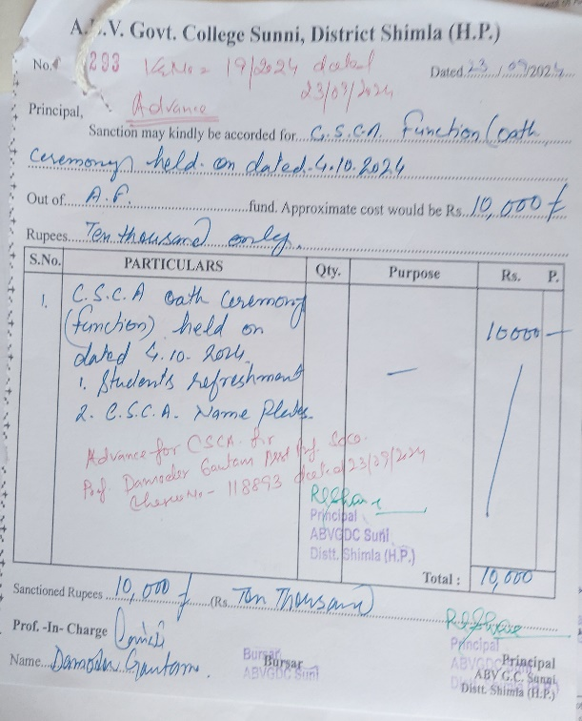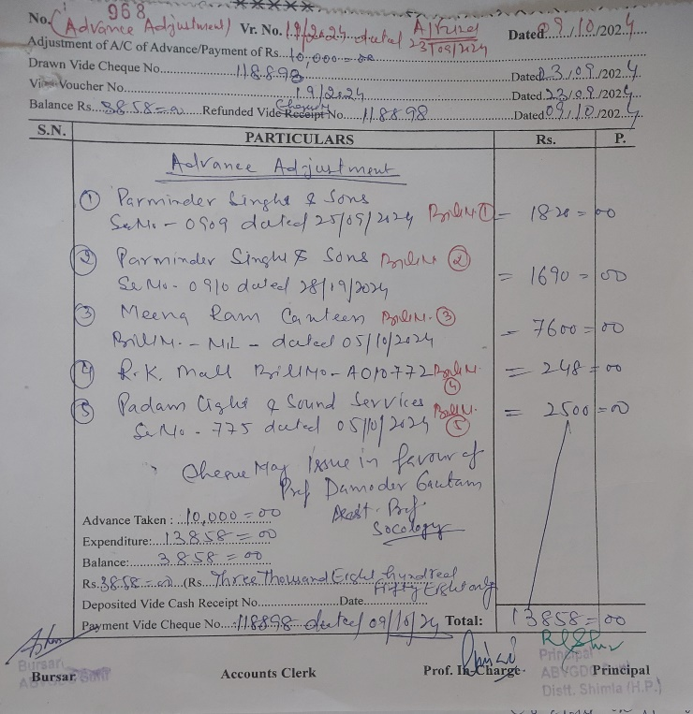

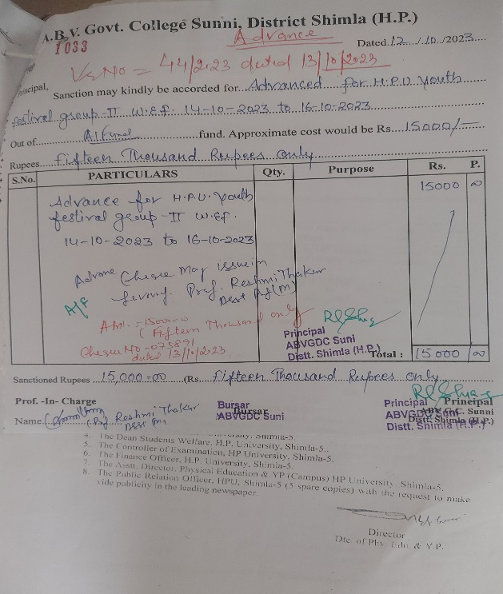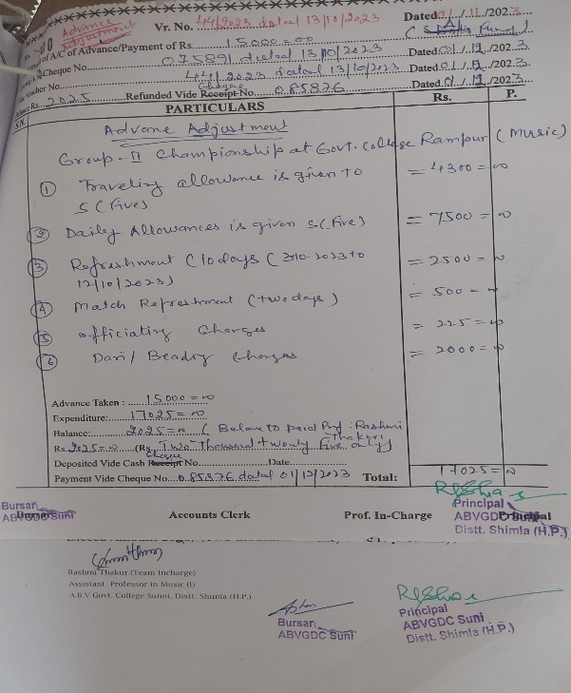

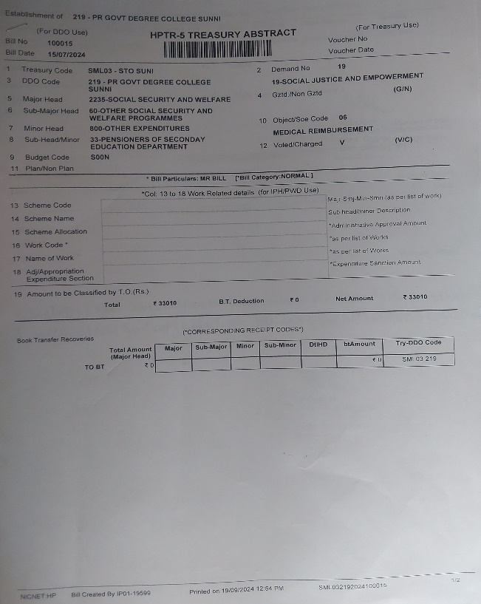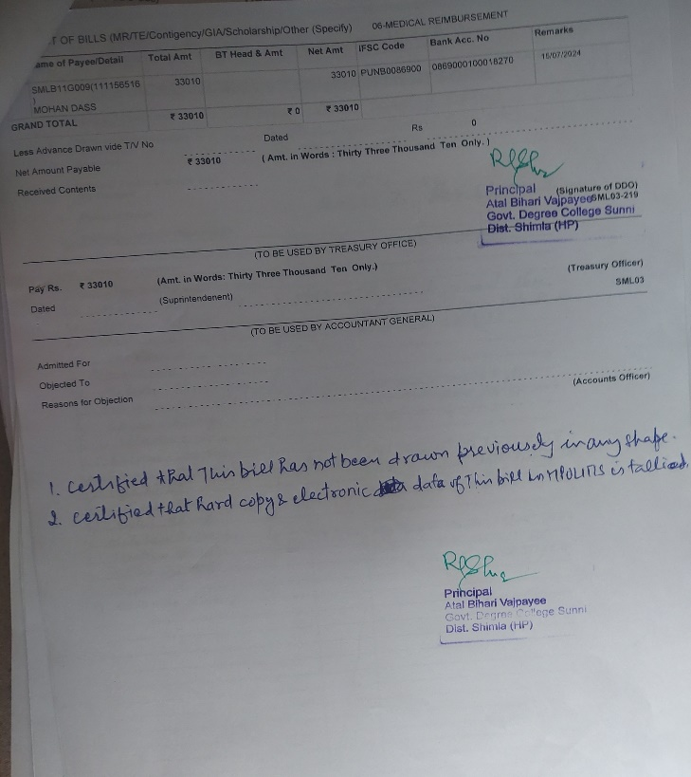

Principal

ABV GDC Sunni, Shimla