**Teaching Methods for Department of Zoology**

The Department of Zoology at Atal Bihari Vajpayee Govt. College Sunni, Himachal

Pradesh, is committed to providing quality education through effective teaching

strategies. The focus is on Lecture-Based Teaching with Innovative Methods, Technology-Based Learning, Flipped Classrooms, and Need-Based Learning,

including Remedial Teaching and Strategies for Gifted Students.

**1**. Lecture-Based Teaching with Innovative Methods

(i) Interactive Lectures: Involving students in active discussions and problem-solving

during the lecture can improve engagement and retention. Short question-answer

sessions, quizzes, or live demonstrations are used to grasp key concepts.

(ii) Visual Aids: Zoology concepts, such as body structures, life cycles are taught with visual aids like charts.

(iii) Short Quizzes During Lectures: Implementing quick quizzes or polls helps gauge

student comprehension in real-time and keeps the students actively engaged

throughout the session.

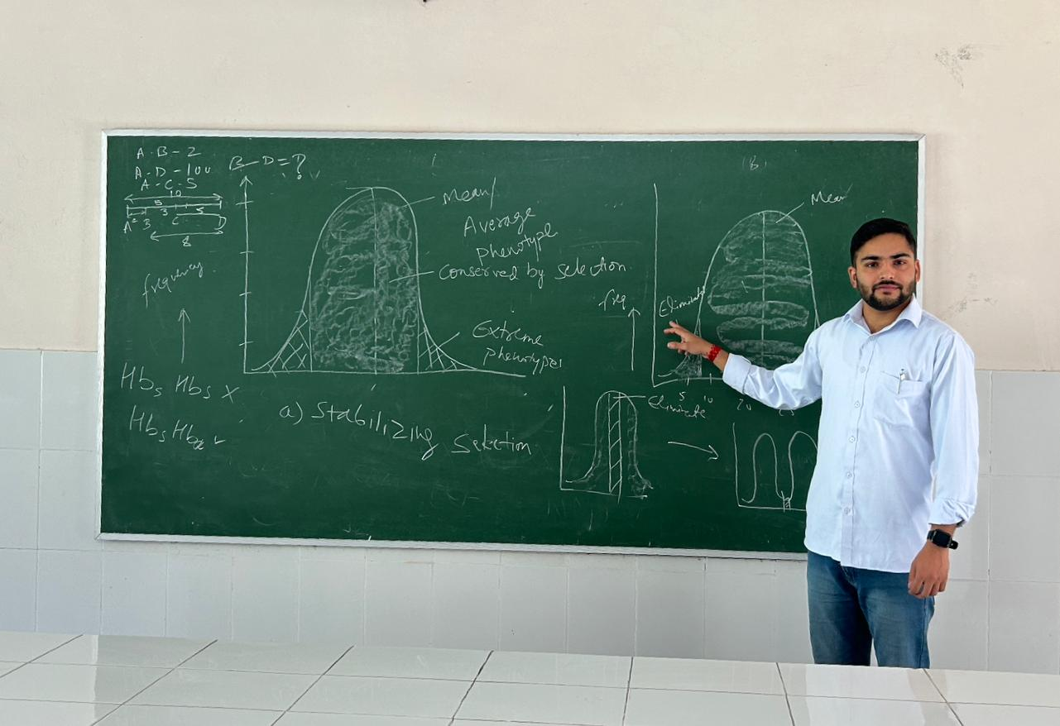

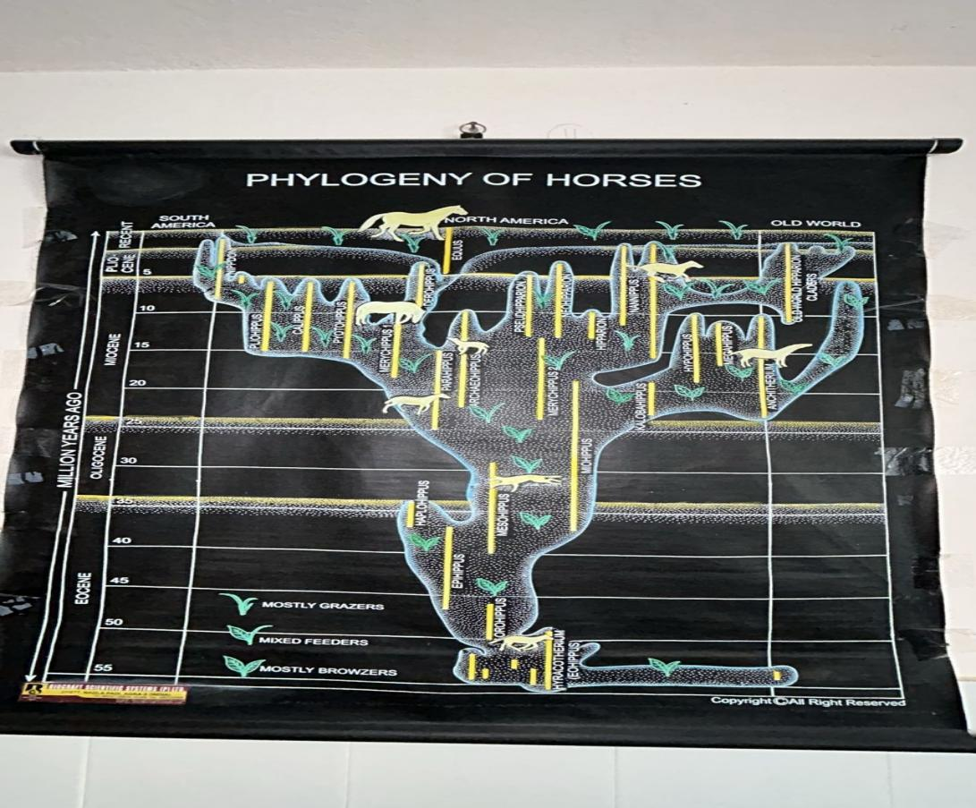

**2**. Technology-Based Learning

Integrating technology into the learning process is crucial in today’s digital age. The

following technology-based methods can improve the learning experience in Zoology:

Learning Management Systems (LMS): Platforms like Google Classroom and whatsapp group allow students to access lecture notes, assignments, quizzes, and additional reading materials. This enhances blended learning, enabling students to learn at their own pace. Use of smart boards, animations and videos are quite helpful to teach complex fundamentals of Zoology especially where lot of imagination is required.

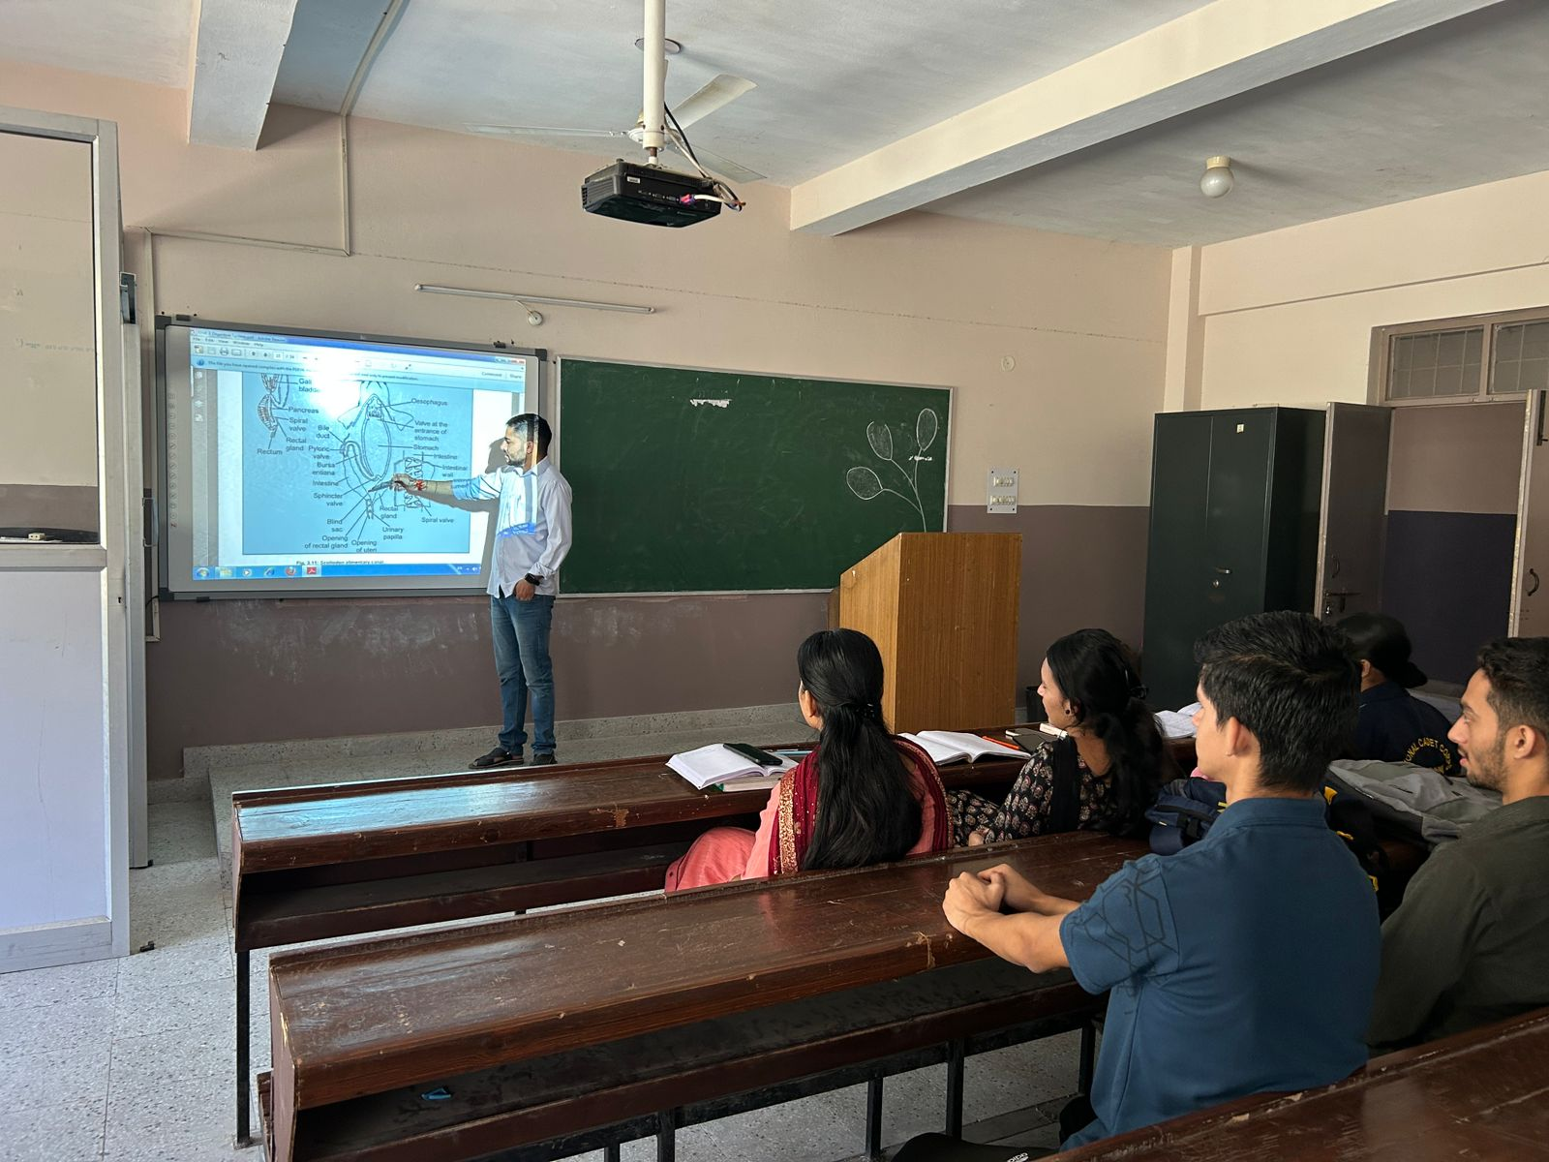

**3**. Flipped Classrooms

Pre-Recorded Lectures: Providing students with pre-recorded lectures allows them to

learn at their own pace before class. This enables the class time to be used more

effectively for discussions and application of concepts.

Problem-Solving Sessions: During class time, students can engage in problem-solving

activities where they apply theoretical knowledge to practical situations, under the

guidance of the instructor.

In-Class Experiment: Using class time for hands-on laboratory work or live

demonstrations of chemical reactions reinforces the concepts learned outside of class.

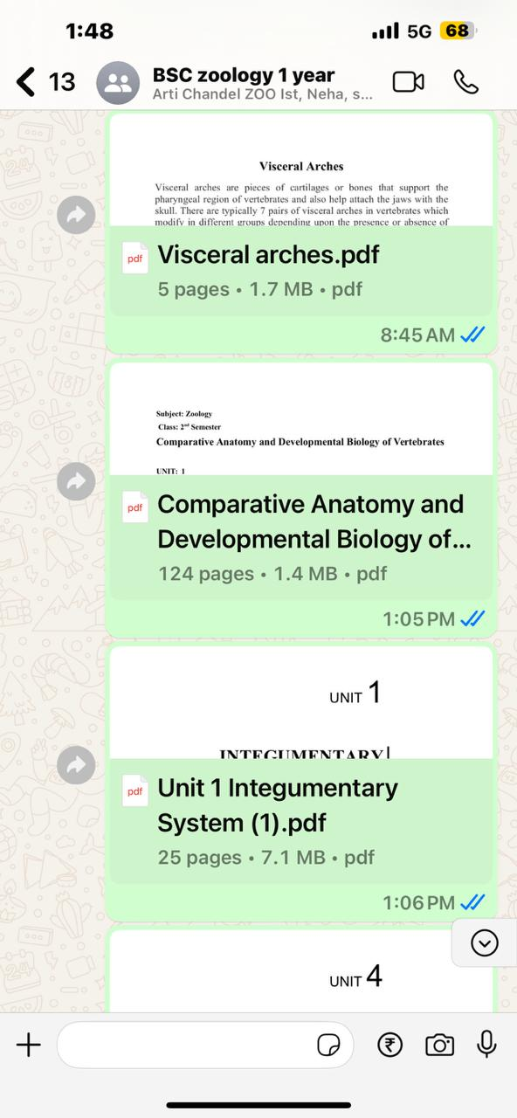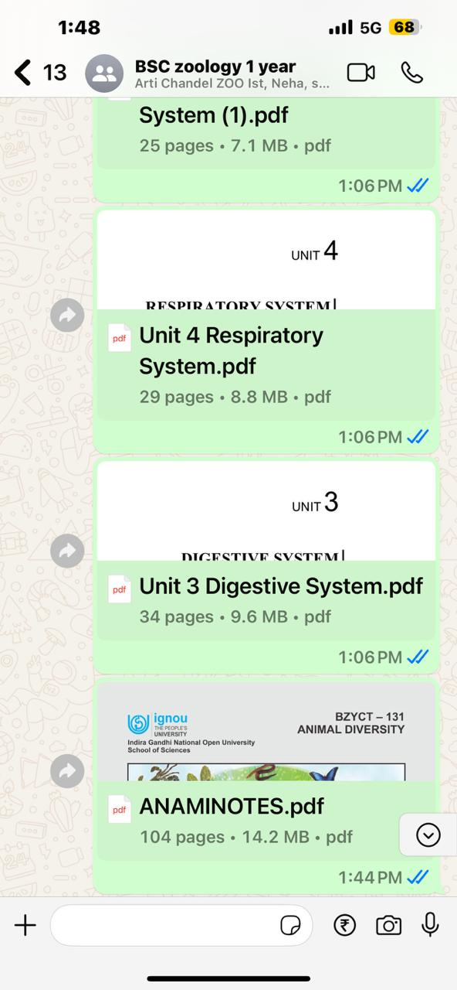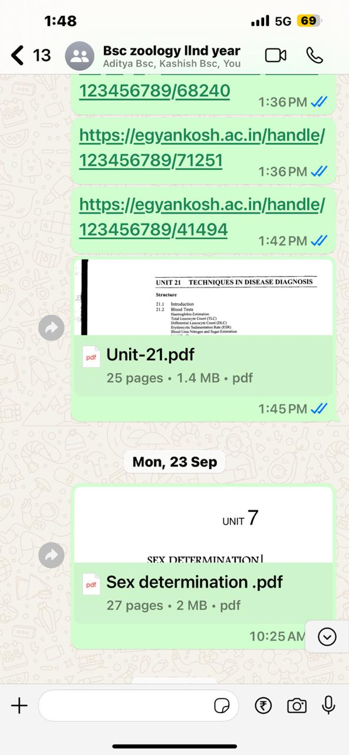

**4**. Need-Based Learning (Remedial Teaching and Strategies for Gifted Students)

a) Remedial Teaching

Additional Tutoring: Offering extra tutoring sessions for students who need help with

fundamental concepts ensures that no student is left behind.

Targeted Assessments: Conducting regular diagnostic assessments helps identify areas of weakness.

Supplementary Resources: Providing simplified explanations, additional exercises, and extra practice materials can help struggling students reinforce their learning.

(iv) Group Discussions and Peer Tutoring: Encouraging students to work together to

discuss and solve problems enhances their collaborative learning and deepens their

understanding of the material.

b) Strategies for Gifted Students

Gifted students need to be challenged to reach their full potential. Some strategies to

engage these students include:

Advanced Topics: Offering gifted students the opportunity to explore advanced or

specialized topics beyond the standard curriculum can keep them motivated and

engaged.

Differentiated Assignments: Creating more challenging assignments for gifted students, allows them to showcase and develop their talents.

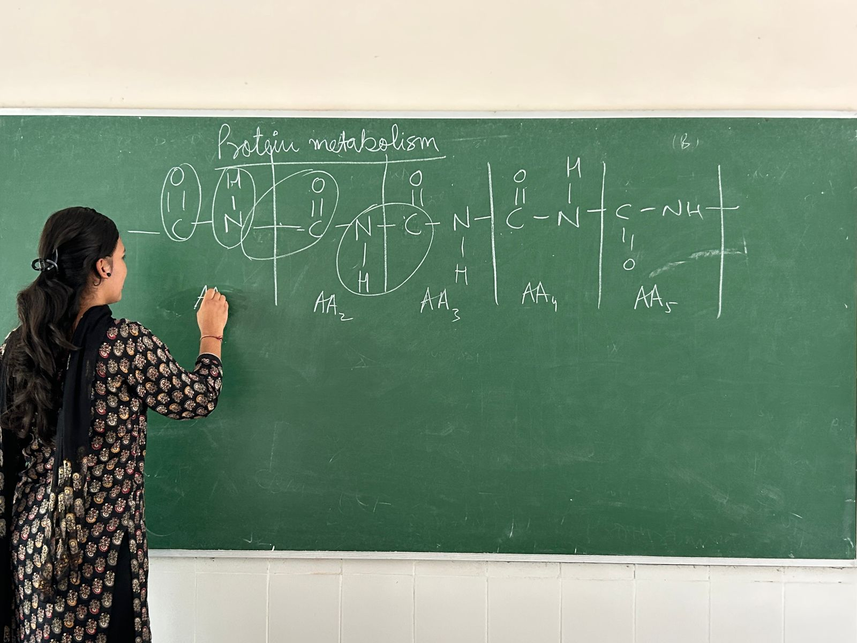

Dharminder Singh Uttam

Assistant Professor

Department of Zoology

ABV Government College Sunni, Himachal Pradesh