**Teaching Methods adopted by Department of Botany**

The Department of Botany at Atal Bihari Vajpayee Govt. College Sunni, Himachal

Pradesh, adopted various teaching methods for fulfilling a committed approach to provide quality education.. The focus is on Lecture-Based Teaching with Innovative Methods, Technology-Based Learning, Flipped Classrooms, and Need-Based Learning, including Remedial Teaching and Strategies for Gifted Students.

**1. Lecture-Based Teaching methods with Innovative approach**

**(i) Interactive Lectures**: Involving students in active discussions and participation during lectures. On the spot problem-solving during the lecture by involving the class help the students in enhancing their thought process, active engagement and retention. For the basic concepts short sessions with quizzes play a vital role.

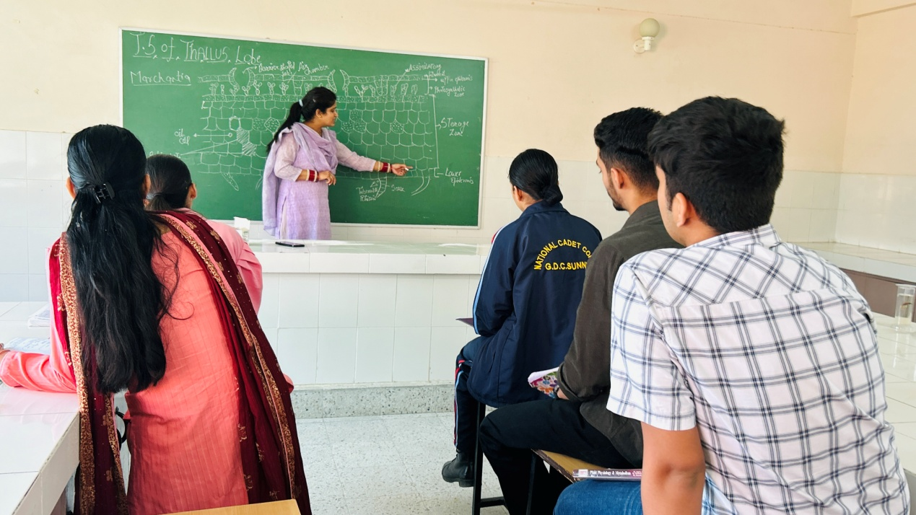

**(ii) Active participation of students**: In this method students are given presentations and assignments to deliver in the whole class with proper teaching mode. This will boost their confidence for future and their approach to listen carefully in the class.

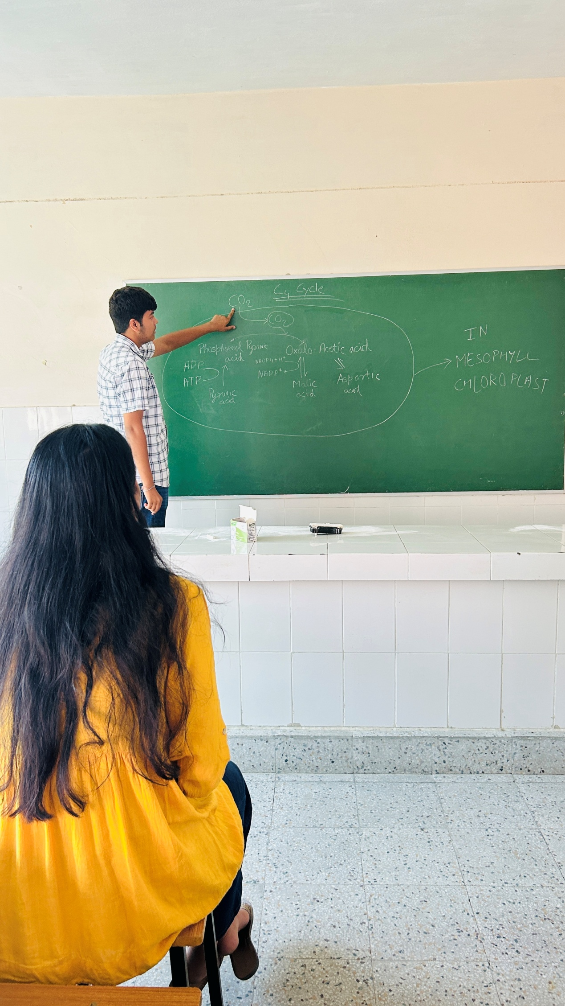

**2. Technology-Based Learning**

In today’s digital era technology is must for filling the gap. Department of botany adopted the various digital plateforms to teach the students like

Google Classroom, whatsapp group. Which allow the students to access lecture notes, assignments, quizzes, and additional reading materials. This enhances blended learning, enabling students to learn at their own pace.Use of smart boards, animations and videos are highly beneficial to integrate and simplify the complex fundamentals of botany.

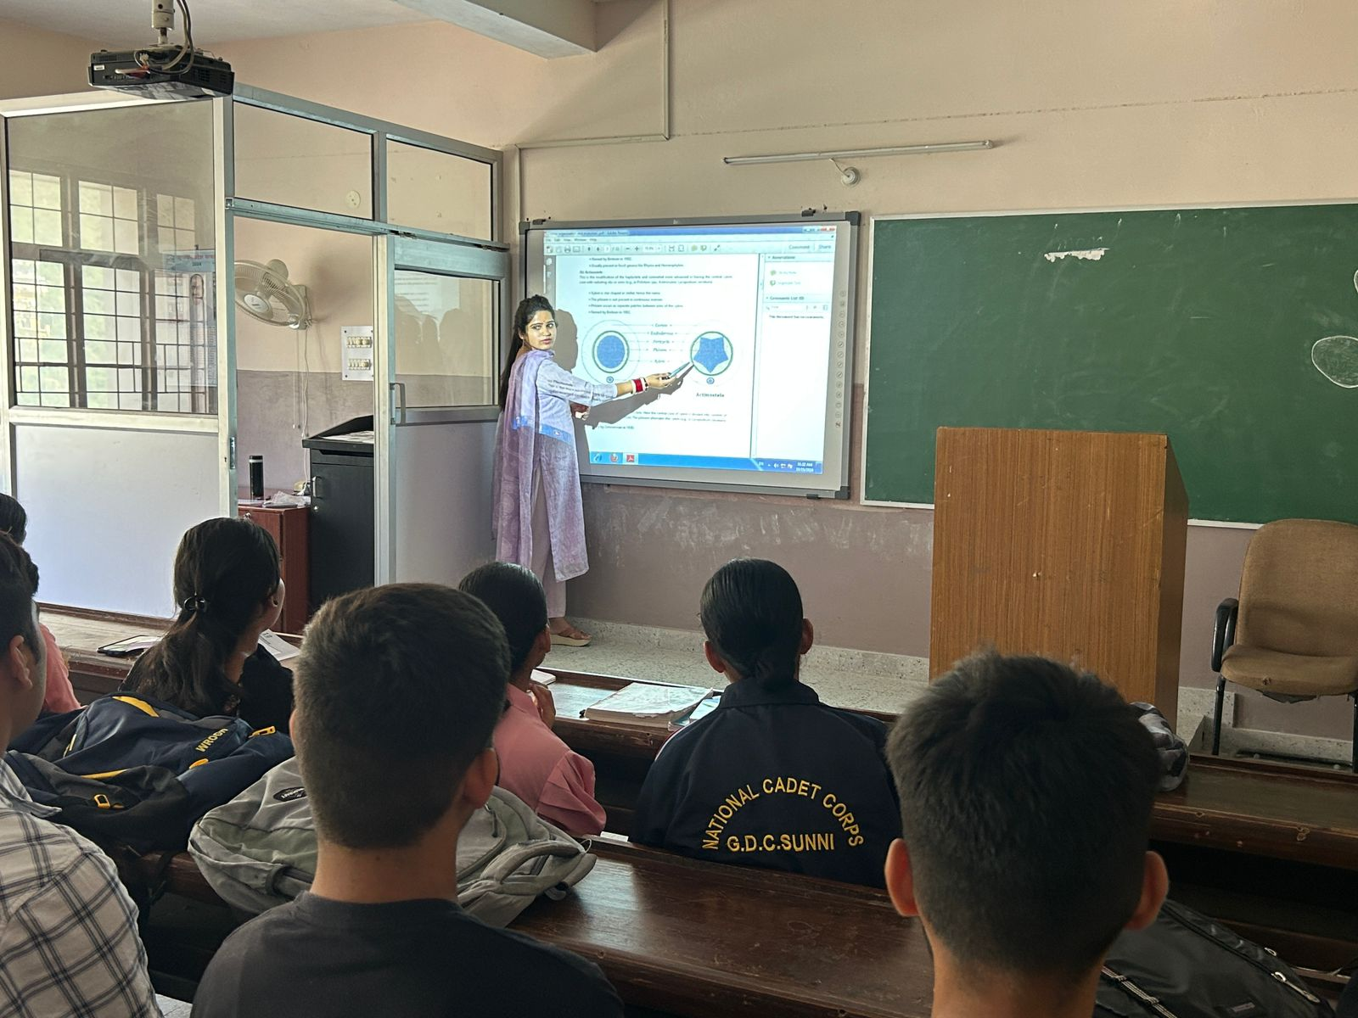

**3. Flipped Classrooms**

This method is quite useful in providing students with pre-recorded lectures allows them to learn at their own pace before class. This enhance their ability to memorize the things fast next day in the class. By this method time will be saved which can be utilized for discussion and short styled quiz.

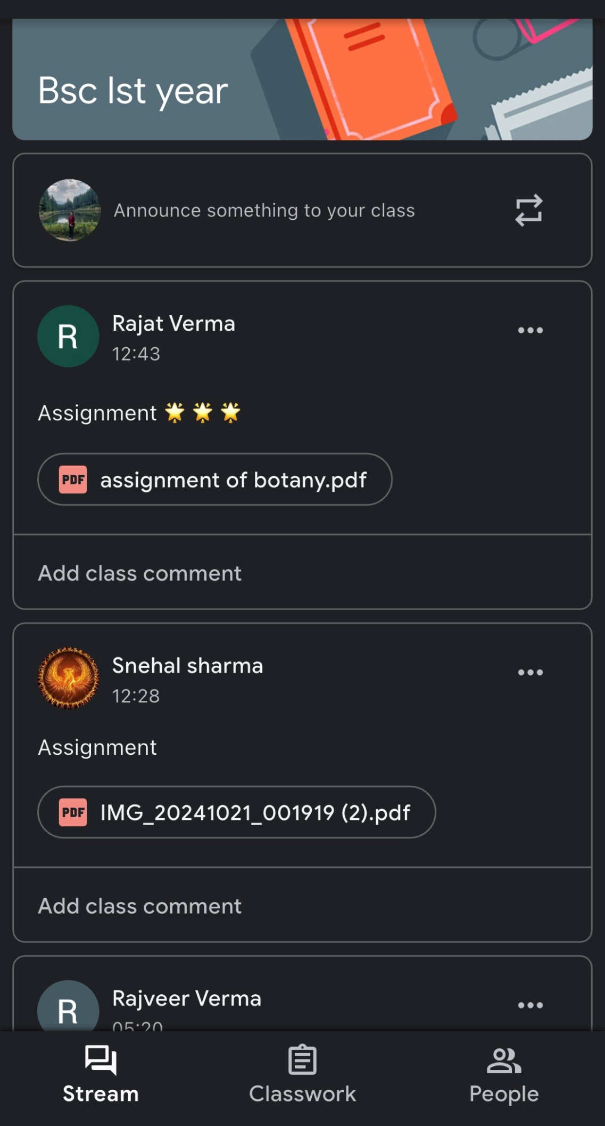**4. 4.**

**4. Practical/ Class Experiment**: As botany subject required a lot of practical knowledge so department adopted a side wise method of practical’s. Like if anatomical part of any plant species is running on lecture mode than in practical class on the same or alternative day dissection, slide and specimen part of same species is done so that students can better understand the concepts by doing the practical themselves.

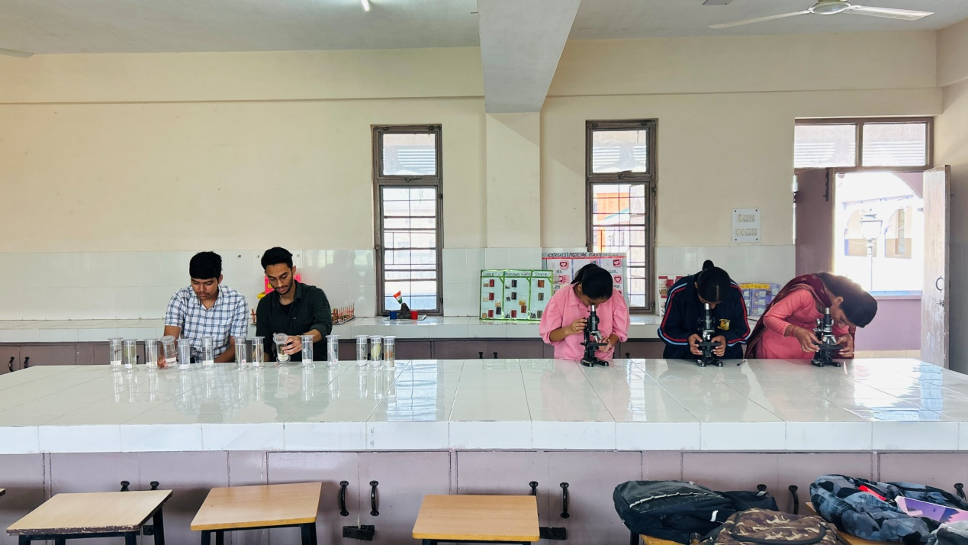

**5. Strategies for weak/Gifted Students**

This section of students need to pay more attention by taking their extra class on teaching day or in holiday time. So that they can utilize their suppress potential to a full extend.

**Dr. Jyoti**

Assistant Professor

Department of Botany

ABV Government College Sunni, Himachal Pradesh